What is Machine Learning?
Machine learning is a branch of Artificial Intelligence that focuses on developing models and algorithms that let computers learn from data without being explicitly programmed for every task. In simple words, ML teaches systems to think and understand like humans by learning from the data.

Machine Learning is mainly divided into three core types:
- Supervised Learning: Trains models on labeled data to predict or classify new, unseen data.
- Unsupervised Learning: Finds patterns or groups in unlabeled data, like clustering or dimensionality reduction.
- Reinforcement Learning: Learns through trial and error to maximize rewards, ideal for decision-making tasks.
Supervised Learning:
Supervised Learning is a type of machine learning in which the model is trained using labeled data, meaning each input is associated with a correct output.
The model learns the relationship between input and output and uses it to make predictions on new data.

Explanation (How to
“Here, the model learns with the help of a teacher.
We provide:
- Input data (features)
- Correct answers (labels)
The model studies this and learns a pattern.”

📊 Example 1: Student Performance
Hours Studied | Marks
2 | 40
4 | 55
6 | 70
👉 If a student studies 5 hours, model predicts marks.
📊 Example 2: Pass/Fail
Hours | Result
2 | Fail
🔹 Types of Supervised Learning
- Regression → Output is continuous
👉 Example: Predict marks, salary
- Classification → Output is categorical
👉 Example: Pass/Fail, Spam/Not Spam

2. Unsupervised Learning

✅ Definition
Unsupervised Learning is a type of machine learning in which the model is trained using unlabeled data, meaning there are no predefined outputs.
The model tries to identify hidden patterns, structures, or groupings in the data on its own.

🧠 Explanation (How to say in class)
“Here, no teacher is present.
We only give data — no answers.
The model explores the data and finds patterns by itself.”

📊 Example: Customer Segmentation
Customer | Spending
A | High
B | Low
C | High
👉 Model groups:
- High spenders
- Low spenders
(No labels given — model discovers this)

🧠 Another Example
👉 Students in class:
- Some study more
- Some study less
Model groups them into categories automatically

🔹 Common Tasks
- Clustering (grouping)
- Association (finding relationships)

🔥 Key Idea
👉 “Model discovers hidden patterns without guidance”
3. Reinforcement Learning

✅ Definition
Reinforcement Learning is a type of machine learning where an agent learns by interacting with an environment and receiving rewards or penalties for its actions.
The goal is to learn a strategy that maximizes total reward over time.

🧠 Explanation (How to say in class)
“Here, learning happens through experience.
The model:
- Takes an action
- Gets feedback (reward or punishment)
- Improves its behavior”

🎮 Example: Game Playing
👉 In a game:
- Correct move → reward
- Wrong move → penalty
Over time, model learns best strategy

🐶 Real-Life Example
👉 Training a dog:
- Sit → reward
- Wrong action → no reward
Dog learns correct behavior

🚗 Applications
- Self-driving cars
- Robotics
- Game AI
REGRESSION vs CLASSIFICATION (10 mins)

🎯 Ask students:
“What type of outputs can we predict?”
👉 Numbers or Categories

🔵 Regression
✅ Definition
“Regression is used when the output is a continuous numerical value.”

📊 Examples
- Predict marks
- Predict salary
- Predict temperature

🧠 Dataset Example
Hours | Marks
2 | 40
4 | 55
6 | 70
👉 Ask:
“If hours = 5 → marks?”
Students: ~60
👉 That is regression

🔵 Classification
✅ Definition
“Classification is used when the output is a category or class.”

📊 Examples
- Pass / Fail
- Spam / Not Spam
- Disease / No Disease

🧠 Dataset Example
Hours | Result
2 | Fail
6 | Pass
👉 Model learns boundary
PART 3: LINEAR REGRESSION (15 mins)

✅ Definition
“Linear Regression is a supervised learning algorithm used to predict continuous values by fitting a straight line to the data.”

🧠 Concept (VERY IMPORTANT)
Say this:
“We try to draw a line that best fits the data points.”
3. Linear Regression (15 mins)

✅ Definition
Linear Regression is a supervised learning algorithm used to model the relationship between independent variables and a continuous dependent variable by fitting a linear equation.

🧠 Core Intuition
“We try to draw a straight line that best fits the data.”

📌 Mathematical Model
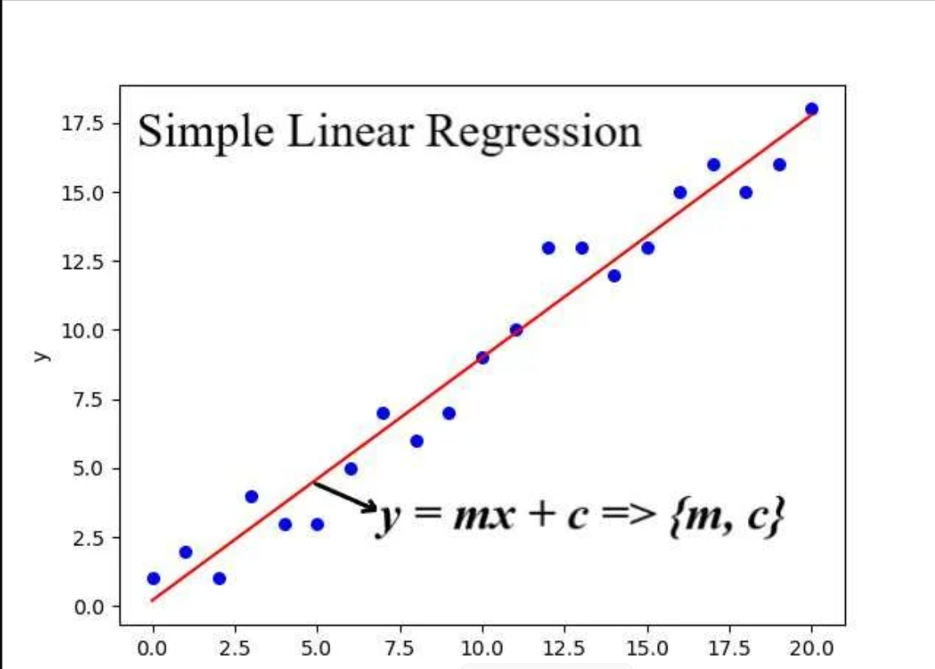

🧠 Deep Explanation
- x → input feature
- y → predicted output
- m (slope) → rate of change
- b (intercept) → starting value

🔥 Key Concept: Error
Prediction is not perfect.
👉 Error = Actual – Predicted
Goal:
👉 Minimize total error

💡 Cost Function (Concept only)
Model tries to minimize:
👉 Mean Squared Error (MSE)
- Squares error to penalize large mistakes
- Ensures best fit line

📊 Example
Hours | Marks
2 | 40
4 | 55
6 | 70
👉 Model learns:
- Marks increase as hours increase
💻 Code
from sklearn.linear_model import LinearRegression
import pandas as pd
df = pd.DataFrame({
"Hours": [2,4,6],
"Marks": [40,55,70]
})
X = df[["Hours"]]
y = df["Marks"]
model = LinearRegression()
model.fit(X, y)
print(model.predict([[5]]))
O/P:
[62.5]

